TECH MAN DAN | Azure Solution Architect / Consultant

Daniel Inman  Azure Solution Architect / Consultant  ──────────────────────────────────────────────────────────────  Northampton/UK | 07799796593  dan.inman@hotmail.co.uk | www.linkedin.com/in/tech-man-dan  Microsoft Cloud Ecosystem Specialist |   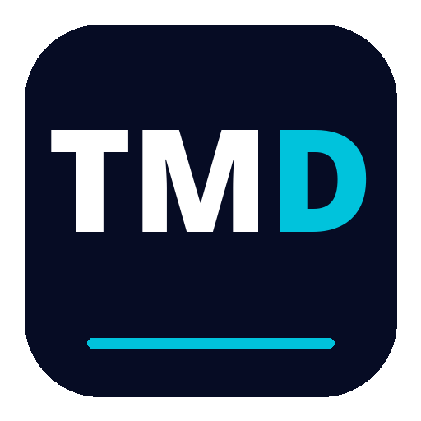

PROFESSIONAL PROFILE  ────────────────────────────────────  A results-oriented Azure Solutions Architect Expert with a proven track record of designing secure, resilient, and cost-optimized cloud platforms in regulated environments. I translate complex business requirements into production architectures using Microsoft Azure Well-Architected Framework principles across reliability, security, performance efficiency, operational excellence, and cost optimization. I specialize in application modernization, high availability and disaster recovery (BCDR), and enterprise governance for multi-tenant organizations. Certified across Azure, cybersecurity, Microsoft 365, Power Platform, and Dynamics 365, I design integrated Microsoft ecosystem solutions that deliver measurable business outcomes.  KEY SKILLS  ────────────────────────────────────  Architecture Patterns and Application Design 95%  High Availability, Resiliency, and BCDR 93%  Security Architecture and Governance 95%  Data and Integration 92%  DevOps and Infrastructure as Code 90%  Stakeholder and Enterprise Architecture Leadership 90%  MS CERTIFIED  ────────────────────────────────────  EDUCATION  ────────────────────────────────────  • BTEC Electronic Engineering | Northampton College | 2011-2013 | STRATEGIC EXPERIENCE  ────────────────────────────────────────────────────────────
   | EXPERT AZ-305  Azure Solutions Architect Expert
  EXPERT SC-100
  Cybersecurity Architect Expert
   | ASSOCIATE AZ-104  Azure Administrator Associate
  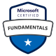 | FOUNDATION AZ-900  Azure Fundamentals
  FOUNDATION MS-900
  Microsoft 365 Fundamentals
  FOUNDATION AI-900
  Azure AI Fundamentals
  FOUNDATION DP-900
  Azure Data Fundamentals
  FOUNDATION PL-900
  Power Platform Fundamentals
  FOUNDATION SC-900
  Security, Compliance, and Identity Fundamentals
  FOUNDATION MB-910
  Dynamics 365 Fundamentals (CRM)
  ASSOCIATE SC-300
  Identity and Access Administrator Associate
  Solutions Architect
  BDO Global
  Remote | August 2024 - Present
  – Application Architecture: Designed a decoupled microservices architecture using Azure Container Apps with Dapr for east-west service communication, alongside API Management (APIM), Azure Service Bus, and Event Grid, migrating business-critical products from Power Platform to a custom .NET and React stack to remove low-code constraints.
  – High Availability: Engineered a multi-region HA model with Azure Front Door, Traffic Manager, and zone-redundant services to support global user traffic and target 99.99% service availability.
  – Disaster Recovery: Authored and tested a disaster recovery runbook using Azure Site Recovery and geo-replicated data services, defining failover and failback procedures to achieve an RTO of less than 4 hours and business-agreed RPO targets.
  – Infrastructure Cost Optimization: Led an Azure estate review and rightsizing program, reducing cloud spend by more than 50% while maintaining performance and reliability SLAs.
  – Resilient Networking: Designing and implementing a multi-tenant Azure Virtual WAN (vWAN) architecture with Azure Firewall, NSGs, and segmented routing patterns to support secure connectivity and regional failover for sensitive workloads.
  – DevOps and IaC: Re-engineered Azure DevOps CI/CD pipelines with environment promotion controls and infrastructure-as-code patterns, doubling deployment speed and improving release quality.
  – Enterprise Governance: Contributed to the global architecture roadmap by establishing multi-tenant security and governance guardrails based on Zero Trust, RBAC, and policy-driven standards.
  Senior Solutions Architect - Cloud - SC Cleared
  AtkinsRealis
  Hybrid, UK Offices | August 2023 - August 2024
  – Promotion and Leadership: Promoted to Senior Solutions Architect in just over a year, leading architecture decisions for secure public sector workloads under SC-cleared delivery constraints.
  – Data Architecture: Designed secure, data-centric Azure platforms for MOD and Network Rail using Azure Synapse and Azure Data Factory with private endpoint and Private Link integration.
  – Resilient Networking: Implemented hub-and-spoke network topologies with Azure Firewall, NSGs, and segmented routing to provide secure, isolated connectivity for sensitive public sector workloads.
  – Architecture Governance: Facilitated architecture workshops and technical discovery, translating requirements into delivery roadmaps aligned to security, resilience, and compliance outcomes.
  – Security and Compliance: Defined Microsoft Purview and M365 DLP controls, strengthening data governance and reducing risk exposure across collaboration and data estates.
  – Team Enablement: Mentored architects and engineers on reference architectures, Well-Architected reviews, and reusable design patterns for public sector delivery.
  Solutions Architect - Cloud - SC Cleared
  AtkinsRealis
  Hybrid, UK Offices | April 2022 - August 2023
  – Requirements to Architecture: Partnered with MOD stakeholders to translate business and security requirements into scalable Azure and Microsoft 365 solution architectures.
  – End-to-End Platform Design: Delivered IaaS and PaaS architectures covering networking, identity, security, and data services, including VNETs, NSGs, Entra ID, Key Vault, Synapse, and Data Factory.
  – Migration and Modernization: Advised on Azure migration and application modernization strategies for public sector programs, balancing reliability, security, and cost-performance outcomes.
  – Data Engineering Integration: Co-designed secure data ingestion and processing pipelines with data engineers, improving data quality, traceability, and operational visibility.
  – Performance and Reporting: Worked with analysts to define technical and business KPIs, enabling service monitoring and optimization through Power BI dashboards.
  Senior Test Engineer - SC Cleared
  Abaco
  On-Site, Towcester | September 2011 - April 2022
  – Led a team of 7 test engineers, ensuring timely and accurate product testing while maintaining high quality standards.
  – Collaborated with IT to design and implement secure data solutions, safeguarding sensitive information and ensuring compliance with industry regulations.
  – Collaborated with other engineering departments to identify and resolve a critical machine performance bottleneck, resulting in a 200% increase in production line speed and throughput.
  – Revamped testing methodologies and equipment, leading to a 100% increase in product throughput throughout the department.
  – Mentored junior team members on product intricacies and best practice testing techniques, fostering a high-performance team culture.
  – Streamlined procedures and workflows, reducing production cycle times by 70% and enhancing overall product delivery.
  – Gained exposure to cloud-based testing environments and tools while collaborating with other departments, sparking an interest in cloud technologies and their potential for scalability and efficiency.

Tech Man Dan | Azure Solution Architect / Consultant | Page 1

